Hospital Configuration-OPD

- OPD Registration Charges: - Entry Card Charge
When a patient comes for consultation first time in the hospital we have to take the Registration charges from the patient. Entry Card Charge can be collected Yearly/ Half yearly etc.

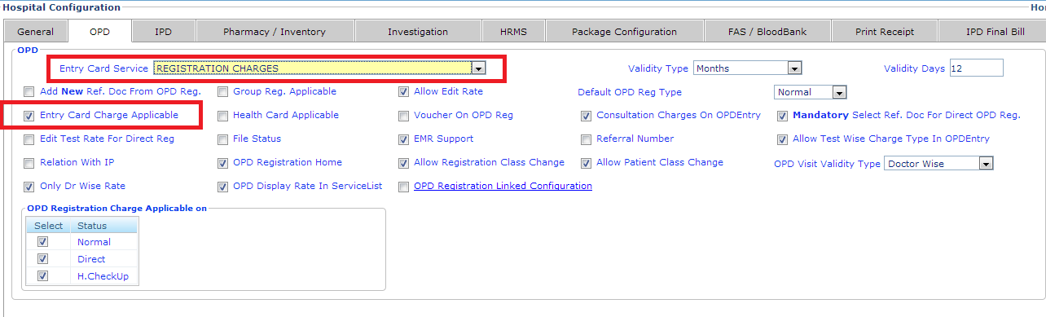
- OPD Consultation Charges at the time of OPD Registration
If we have to collect the OPD Consultation charges (New/ follow up) at the time of registration.

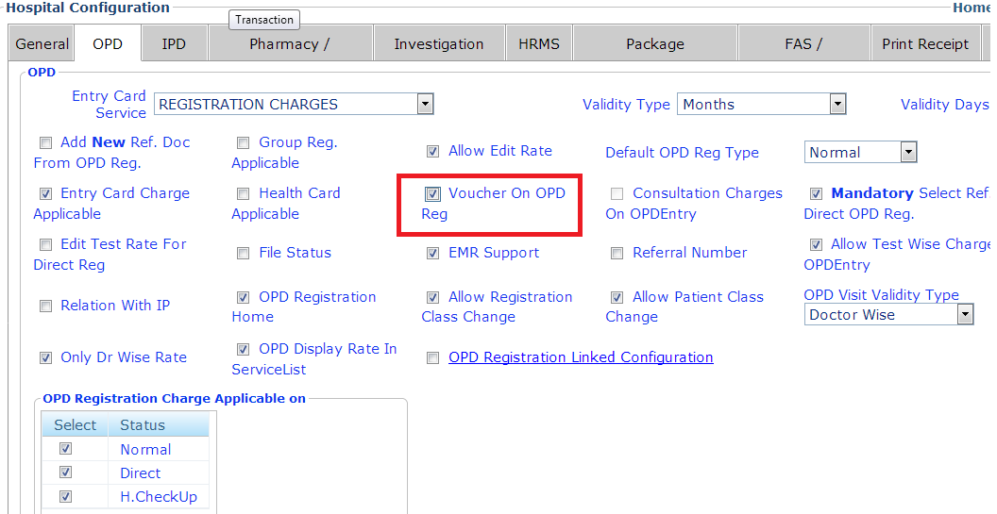

- OPD Consultation Charges after consulting Doctor
If we to collect the consultation charges from the patient after consulting with doctor.

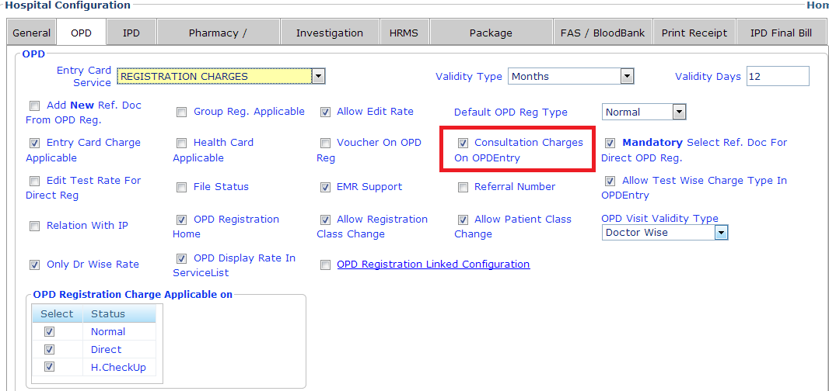

- Doctor Wise OPD Rates
If the consultation charges are different for specialty then we use the doctor wise OPD rates to set the consultation charges according to the consultant.

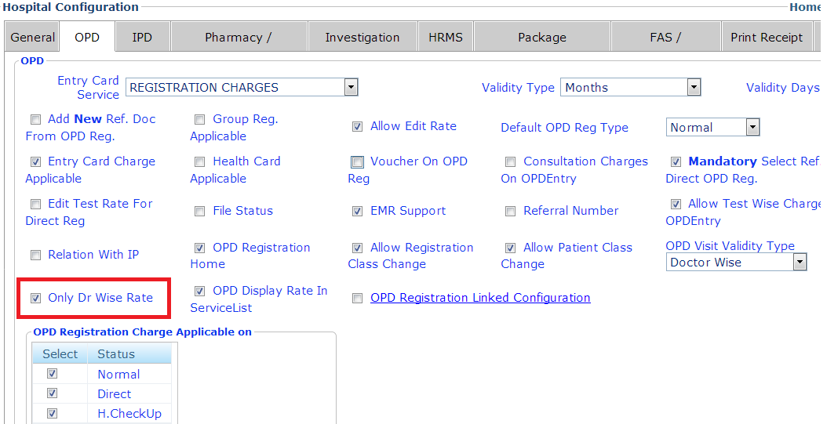

To Set Dr. Wise OPD Visits:
We can configure the consultation charges for a particular consultant.

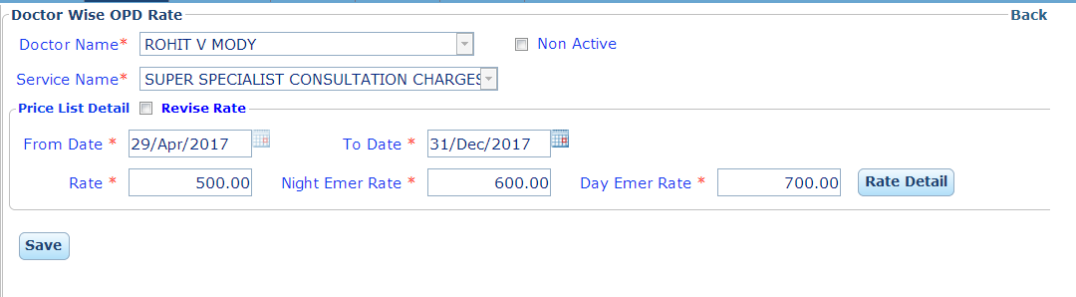

- Fixed Rate: Rates are fixed for all Services.
We can configure the charges for all services provided by the Hospital in Masters and this rates can't be changed by any user.

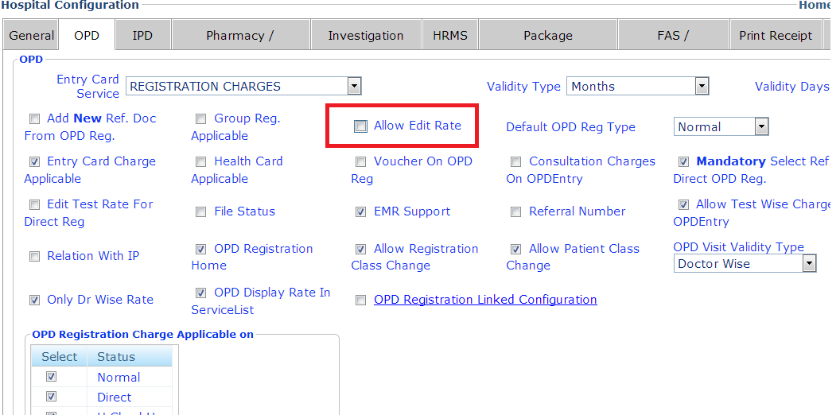

- Edit Rates:

User can chance the service charges as prescribed by Doctor manually on Paper or telephonically. We can configure the charges for all services provided by the Hospital in Masters and this rates can't be changed by any user.

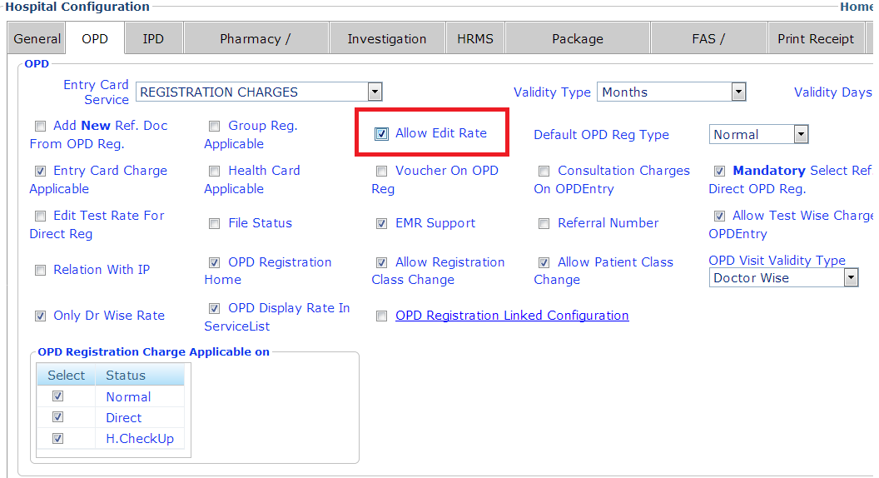

- Rate would be decided by Doctor Approval / Call By Nurse
Sometimes we have to collect the different consultation charges from different type of patient for a particular doctor. So we can take the consultation charges accordingly.

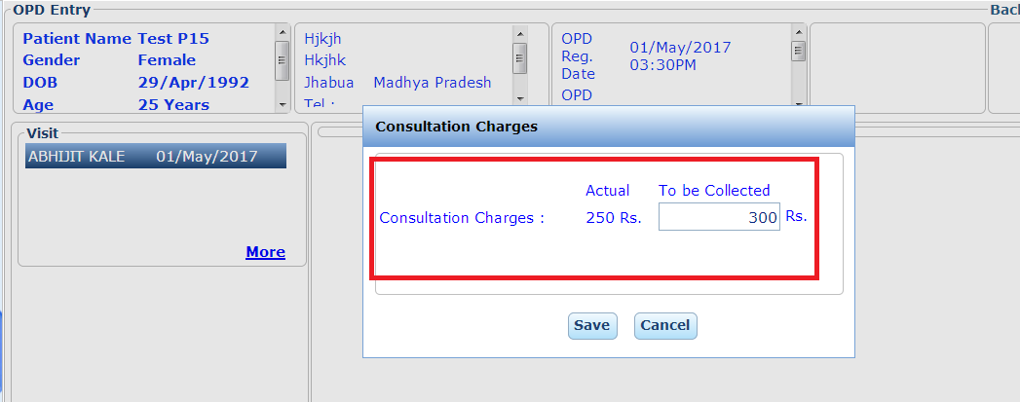
- Group /Department / Unit Wise Registration:
This facility is used when there are unit of doctors in which patient is registered and patient is consult by either unit/Dpt. Head or any one from their Group Members.

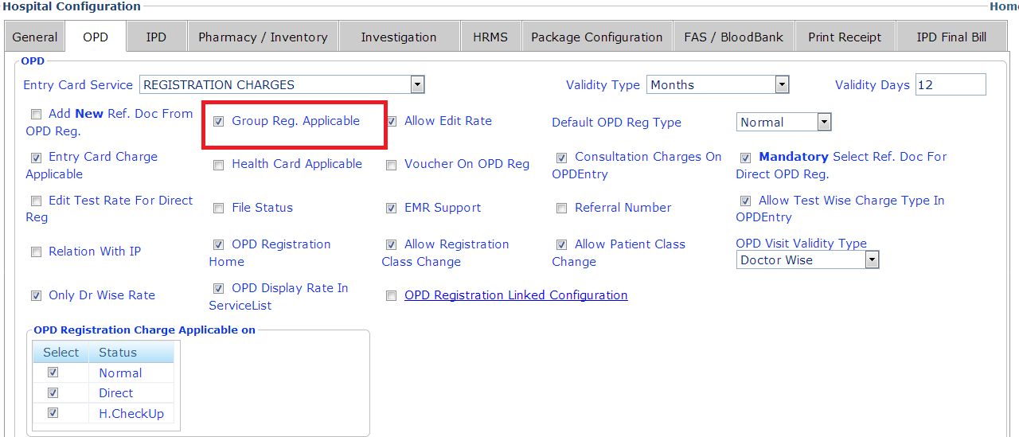

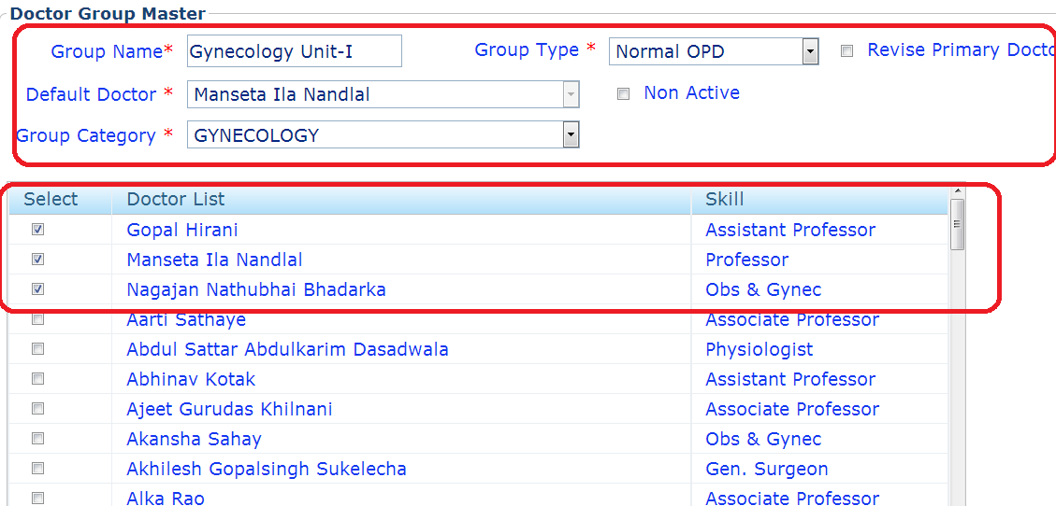

- Appointment Booking Expiry:
We can set the expiry days for the appointment of the patient. After the limit of expiry the appointment of the patient canceled by the system automatically.
